

Database Systems

Assignment no: 3

For all sections

Deadline: 25th March 2020

2020

Note:

Tables are given in the .txt file.

# Question no: 1

By using the p (product) table to do the following. (Using basic queries).

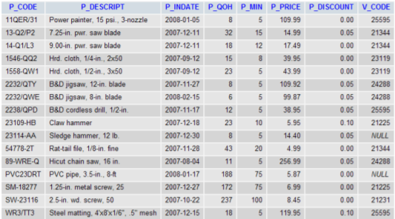

1. Retrieve the average quantity on hand along with vendor code amongst those products that has the vendor code ‘21344’.
2. Retrieve the minimum price along with vendor code amongst those products that has no vendor
3. Retrieve the maximum price amongst the products that has a vendor.
4. Retrieve the average price of the products that has no discount.
5. How many products have the discount .05 and how many have discount 0.

# Question no: 2

By using the emp (employee) and dept (department) table to do the following (Using subqueries).

1. Display the employee who got the maximum salary.
2. Display the employees who are working in Sales department.
3. Display the employees who are working in “New York”.
4. Find out no. of employees working in “Sales” department.
5. List out the employees who earn more than every employee in department 30.
6. List out the employees who earn more than the lowest salary in department 30.
7. Find out whose department has not employees.
8. Find out which department does not have any employees.
9. Find out the employees who earn greater than the average salary for their department.

# Question no: 3

By using the emp (employee) and dept (department) table to do the following (Using Joins).

1. Display employees with their department name.
2. How many employees who are working in different departments and display with department name.
3. How many employees who are working in sales department.
4. Which is the department having greater than or equal to 5 employees and display the department names in ascending order.
5. List out the total salary of each department
6. Display employee details with all departments.
7. Display the employee details with their manager names.
8. Display the employee details who earn more than their managers' salaries.
9. Show the no. of employees working under every manager.

Submission guidelines:

* Paste screenshot of your queries with output.
* Deadline: 25-March-2020

Stay Safe, Happy Holidays ☺